Sri Lanka Institute of Information Technology



Lab Submission

<Lab sheet 06>

**<IT24100963>**

**<Demel W.J.L>**

**Probability and Statistics| IT2120**

B.Sc. (Hons) in Information Technology

Exercise

1. i)

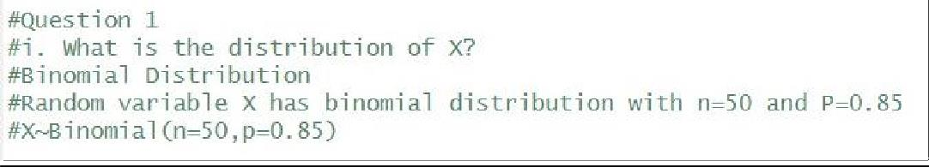

ii)

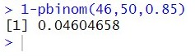

1. i)

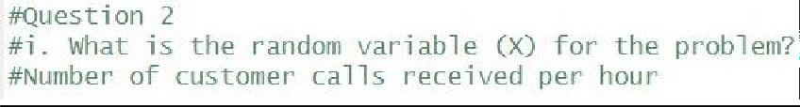

ii)

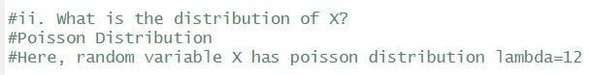

2. iii)

